**Matrix Exponentiation**

This is very helpful in solving recurrence relations. One of whose examples is

fibonacci numbers.



In matrix exponentiation , we try to find a matrix which can convert k

th state to (k + 1)th state, i.e.



On solving we get a = b = c = 1 and d = 0. Our matrix becomes



Since by multiplying once we reach on we reach on (n + 1)th state from nth

state. In the same way we reach on (n+k)th state from nth state by multiplying

M matrix k times with our original matrix.

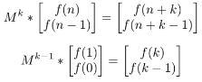

We can compute Mk−1 in log(k) time. Using these equations this can be done



**Various helpful Recurrence Relations**

Recurrence relations can be solved very easily. We can find the M matrix just

by analyzing.

Various examples are

1. **f(n) = a*f(n-1) + b*f(n-2)**



1. **f(n) = f(n-1) + f(n-2) + c**

Here 3 variables are involved , f(n-1) , f(n-2) and c. Therefore our M matrix will be of 3x3.

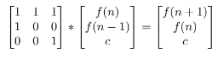

1. **f(n) = f(n-1) + f(n-3)**

This can be further written as f(n) = f(n-1) + 0*f(n-2) + f(n-3). So here also 3 variables are involved, that are, f(n-1) , f(n-2) , f(n-3). Hence a 3x3 matrix will be formed.

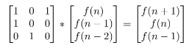

1. **f(n) = a*f(n-1) + c*f(n-3) + d*f(n-4) + e**

This can be written as f(n) = a*f(n-1) + 0*f(n-2) + c*f(n-3) + d*f(n-4) + e Therefore, here 5 variables are involved viz f(n-1) , f(n-2) , f(n-3) , f(n-4) , e. Hence a 5x5 matrix will be formed.

